**Term Project Phase 2 - Process Discovery**

**Syed Farhan Jafri (21L-6074)  
Shaaf Salman (21L-6083)  
Laiba Habib (21L-6102)  
Abdul Hadi (21L-6077)**

**Process Discovery Methods**

The main process discovery methods that were used were Evidence-Based Discovery and Interview-Based Discovery.

The Evidence-Based Discovery mainly consisted of all three Document Analysis, Observation and Automated Process Discovery.

During the document analysis stage, the main documents that were read through or analyzed was the application form which stated the requirements/needs of filling an application and what other supporting documents are needed to apply for a new/renewal of a passport. Other documents included guidelines and a policy manual for the passport office. These were reviewed to identify processes and requirements.

During the Observation stage, some time was spent during office hours to figure out a pattern of the processes and establish a sequence of steps of each process. The mass and workers were observed to see their work. For example, when a new customer came to apply for a new passport. They first had to fill an application form and provide the required documents to a handler assigned to them. The assigned officer would verify the documents, payment and other details and then approve the form. The application was then forwarded to a manager who was to conduct an interview of the applicant in order to approve them for a passport. Once approved, the application was signed and an approval sent to the printing facilities to produce said passport.

During the Automated Process Discovery, one of our group members, Shaaf, went and applied for the renewal of his passport. After days of hustle and learning the processes through the hectic busy schedule of the office. His passport was finally renewed after almost 2 months of appointments and waiting. During this time, he learned all the steps involved and processes involved.

During the Interview-Based discovery, an interview was conducted of an officer/handler. We could not get access to a higher-level officer so had to settle for an application officer. An interview of 5-7minutes was conducted during which a present questionnaire was asked and some on the spot questions were asked. An external manager was also interviewed and the process learned. The questionnaire and response are attached below as they are hand written.

**Evidence**

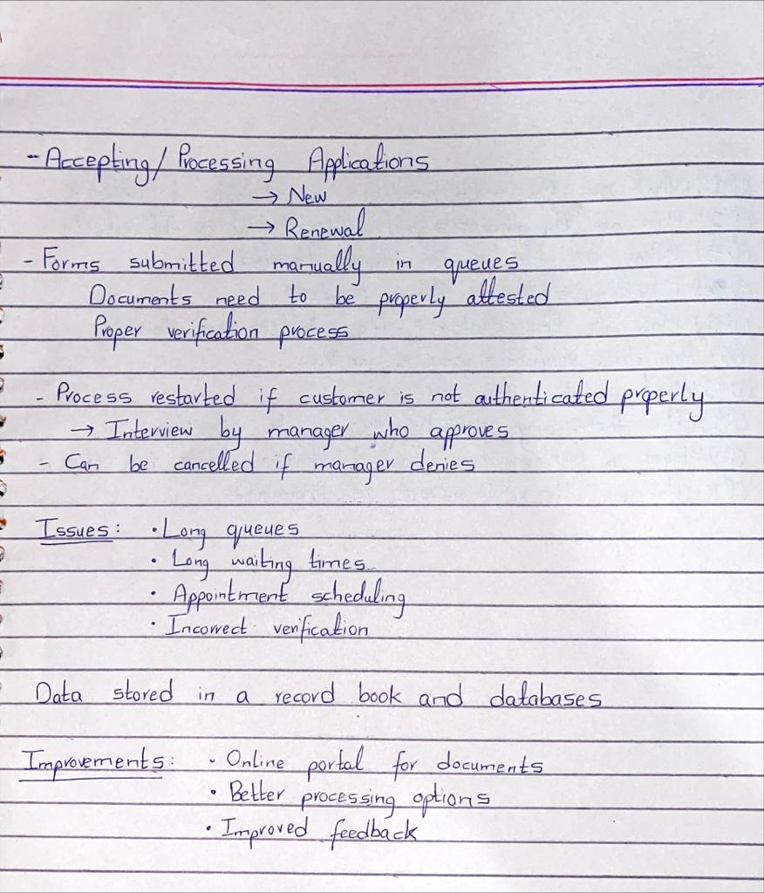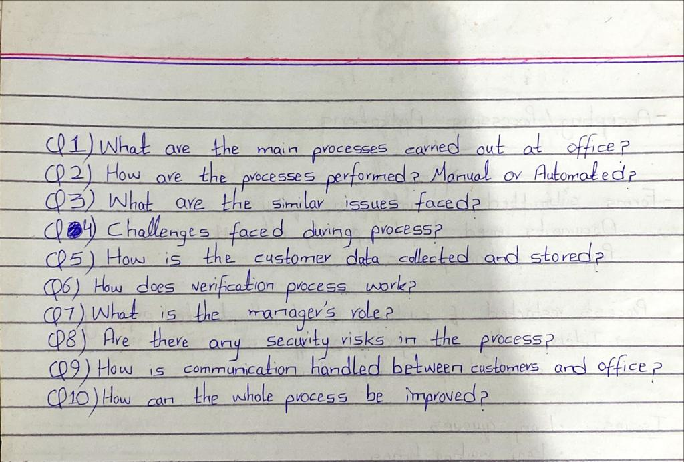**Interview Questionnaire and Responses**

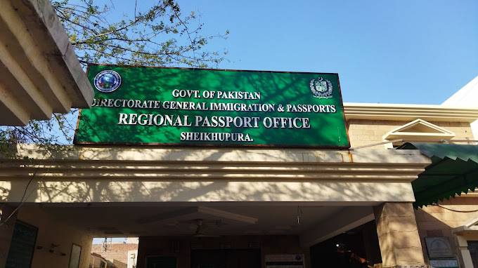**Visit to the Office – Sheikhupura Branch**

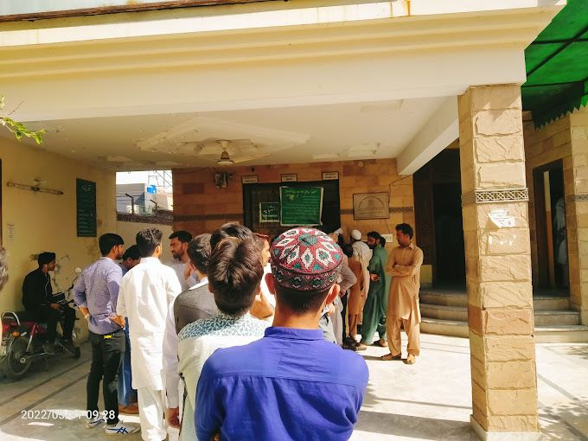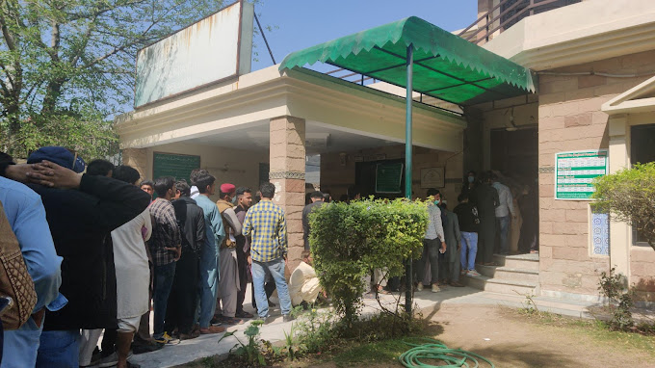

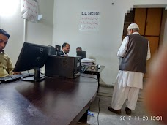

**AS-IS BPMN Models**

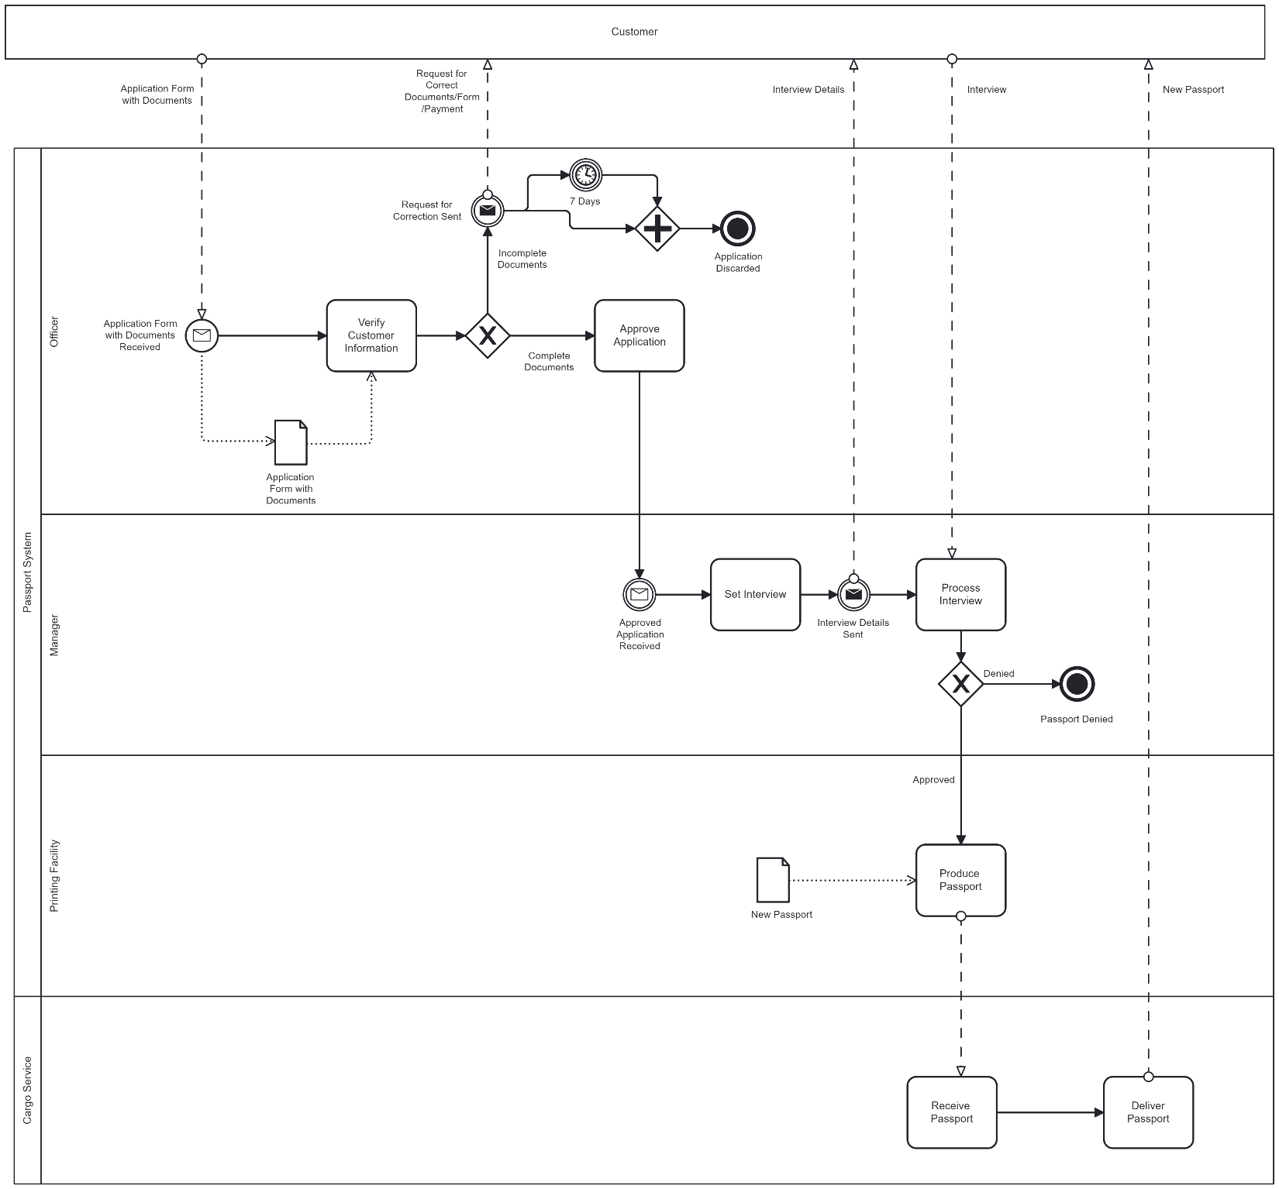**1) New Passport**

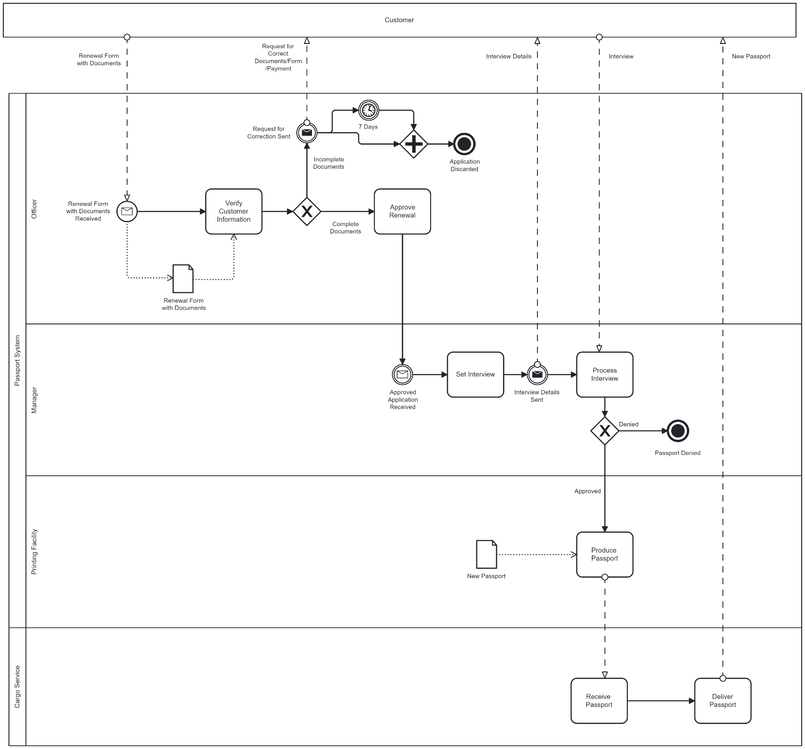**2) Renewal of Passport**

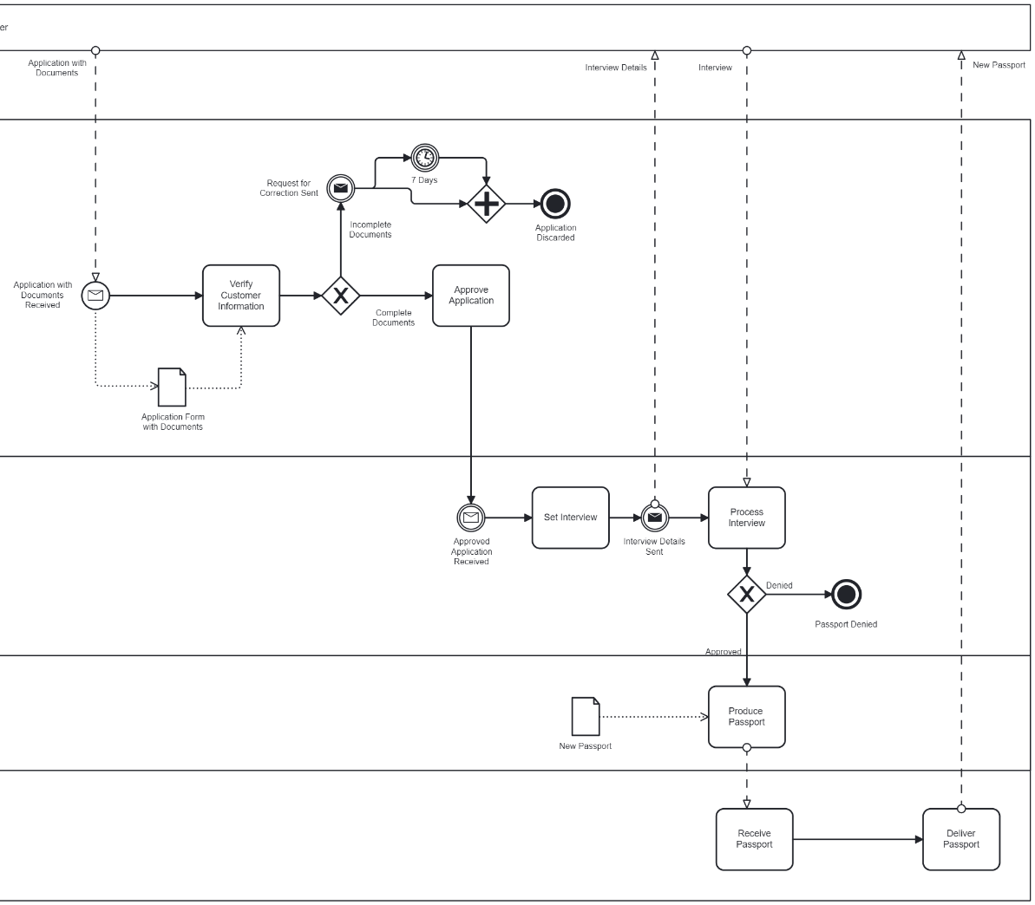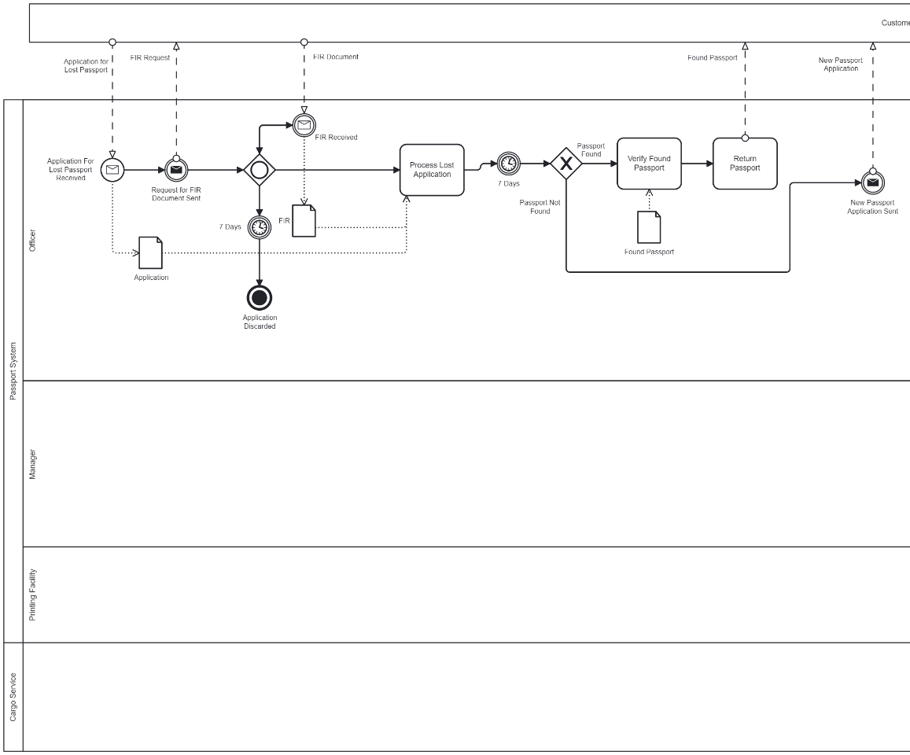**3) Lost Passport (could not fit the diagram fully on one page so broke it in half/you can view the whole thing in the bpmn files attached)**

**4) Data Storage**

